Tutorial – Single-Phase Inverter

Description
This tutorial guides you through the implementation of a single-phase inverter model using the DL 2106T06 module with bidirectional serial communication between a Simulink-based Host Model which will be running in the master (PC) and a Target Model running on DL RCPCORE module. The system implements basic control, monitoring, and fault protection based on real-time analog acquisition and serial communication.

Learning Objectives
By performing this experiment, students will learn about the single-phase inverter, while reaching the following main objectives:
- Understand how to configure the DL 2106T06 as a single-phase inverter.
- Construct master–target models in Simulink, with the Host model dedicated to debugging and monitoring, while the target model executes control algorithms, performs data acquisition, and integrate protection logic with constraints.
- Implement serial communication between the host and target.
- Implement protection logic for safe inverter operation.
- Monitor DC-link voltage, inverter current, and fault status in real time.

Part 1: Set up a single-phase inverter
The DL 2106T06 is a module that integrates a controlled single-phase rectifier, a DC link, and three IGBT legs at the output. The module was originally designed to function as a frequency converter. Nevertheless, owing to the independent controllability of its output inverter, it can also be employed to construct other types of power converters. In this tutorial, we use it as a single-phase inverter for an RLC load.
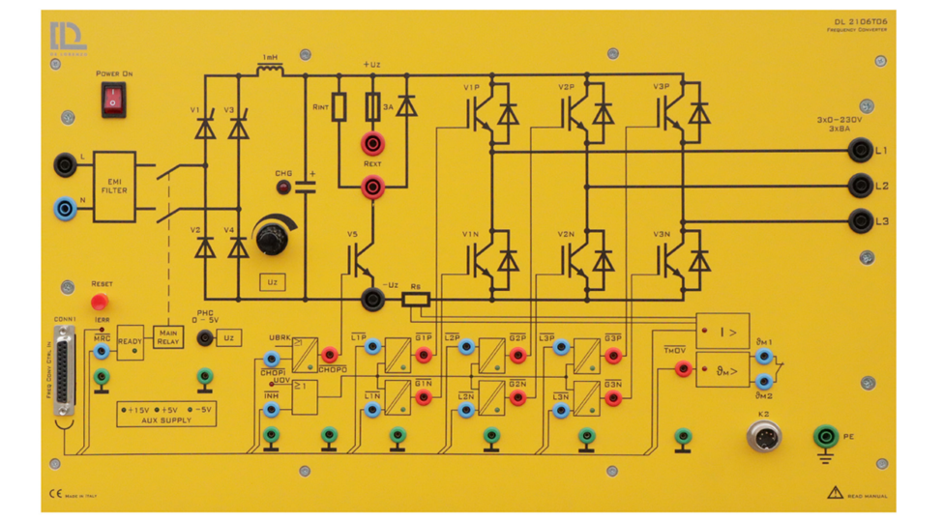
To use the DL 2106T06 frequency converter as a single-phase inverter, the system must be reconfigured in the following way:
- Leg 1 of the output inverter: only the upper IGBT (V1P) is controlled using PWM and receives a duty cycle D. The lower IGBT (V1N) receives the complementary duty cycle(1-D).
- Leg 2: The lower IGBT (V3N) is forced on to provide a valid return path for the converter current back to the power supply.
- Leg 3: both IGBTs are off since this leg is not used in the single-phase inverter.

Part 2: Construct Simulink Host and Target Models
To open the example for reference, run openDLDemo(‘1p_inverter’) in the command window.
Create a folder for the new project
💡 It is recommended that each project has its own separate folder, and the folder path does not contain any spaces.
Navigate the MATLAB working directory to the new project folder
Execute the CreateNew command in the MATLAB Command Window and enter the project name in the pop-up dialog box.
💡 Avoid using special characters and spaces in the project name.
Wait until the "Busy" status in the lower-left corner of MATLAB disappears, and no warnings or errors are displayed in the Command Window.
Two models are created by the system:
- Target model: This model will be compiled, deployed, and executed on the DL RCPCORE hardware. Its primary responsibility is to execute control algorithms and support real-time communication with the host model.
- Host model: This model runs on the PC in simulation mode. Its role is to debug parameters in the target model and display specific signals.
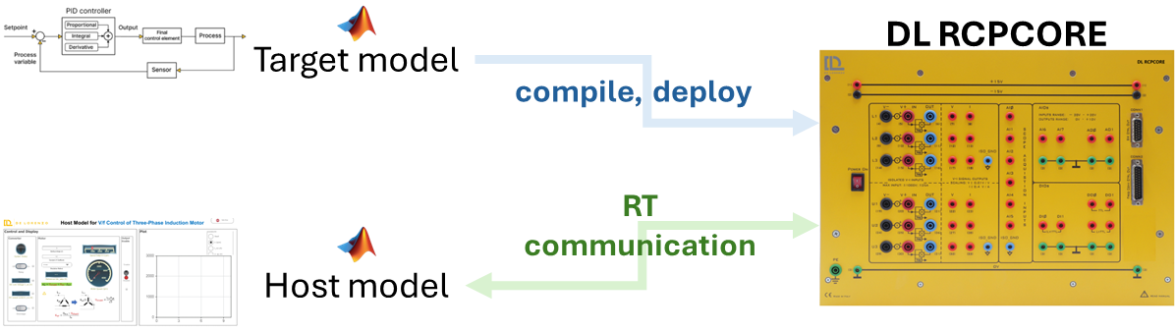
An .m file for setting parameters will also be generated automatically.

Step 1: Target Model Structure and Basic Blocks
In the target model, the essential blocks have been added. Read the descriptions and warnings of these blocks to understand their significance and function as essential blocks.
Navigate through the Simulink Library Browser to locate the blocks in the DL library that are required to interface the model with the DL PEL-HIL hardware modules. Add the following blocks:
- Dual-INT: The Dual-Interrupt block is used to enable hardware-triggered execution of two key tasks on the target microcontroller: the ADC interrupt (ADC), which ensures precise and timely execution of ADC conversion and related control routines, and the RX interrupt (RX), which allows efficient reception of serial data only when needed, saving processing resources. By relying on hardware interrupts instead of fixed sample times, the model becomes more reasonable and practical.
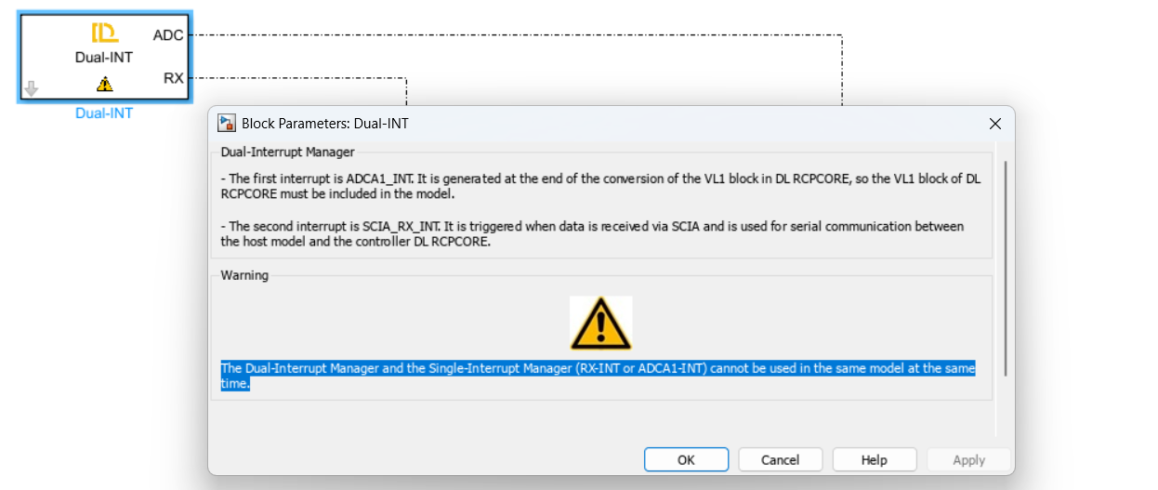
- Preassign key variables in RAM for real-time access using the Data Store Memory block.
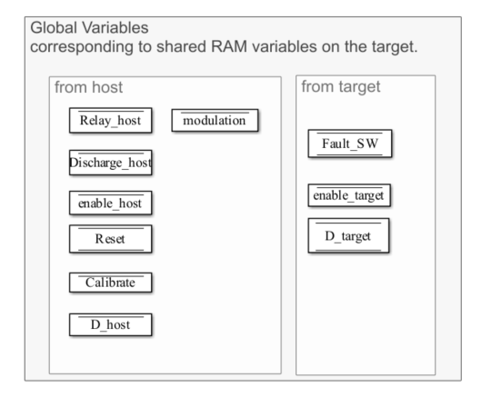
  - Relay_host (Boolean signal)
Relay control signal sent from the host; whether the target follows it depends on the protection algorithm.
  - Discharge_host ( Boolean signal)
DC link discharge control signal sent from the host; whether the target follows it depends on the protection algorithm.
  - enable_host (Boolean signal)
Enable control signal sent from the host for IGBT o; whether the target follows it depends on the protection algorithm.

  - Fault_SW ( Boolean signal )
Based on the results of the software protection algorithm specifically defined for this project. Please distinguish it from hardware fault triggered by hardware protection. The determination of hardware fault is performed entirely by the hardware.
  - Reset ( Boolean signal)
A signal sent by the host to clear latched software faults.
  - Calibrate (Boolean signal )
A signal sent by the host to enable hardware data acquisition offset calibration.
  - D_host (Single signal)
A signal sent by the host to drive IGBT V1 with a duty cycle ranging from 0 to 1.
  - Modulation (single signal)
A signal sent by the host to activate the chosen modulation technique
- 0 for square wave modulation.
- 1 for SPWM modulation.
- 2 for 3rd harmonic injection modulation.
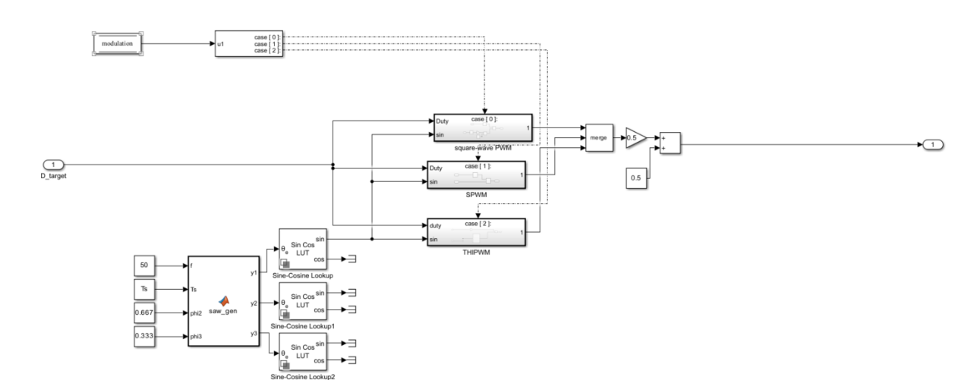

💡 Do not forget to specify the Data type of the stored data through Signal Attributes tab, as it is important for efficient and correct communication. Please refer to Host-Target Communication – Fundamentals in DL PEL-HIL Getting Started to understand the recommended type of data to be used.
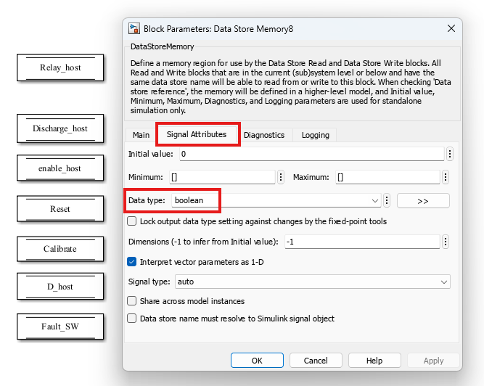
- Create two subsystems and connect them to the two outputs of the Dual-INT block to perform their specified functions as explained before.
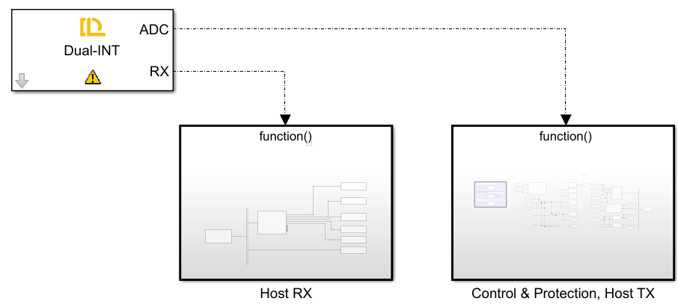
The first subsystem is for receiving serial data from the host through Target RX Block and writing those data to their specified data store memory blocks to allow them to be read elsewhere in the model.
💡 please refer to Host-Target Communication – Fundamentals in DL PEL-HIL Getting Started to understand how the serial communication between host and target works, and what parse blocks is used for.
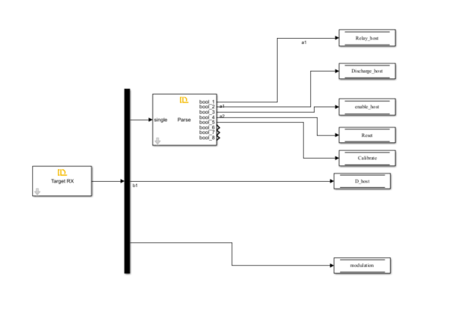
In this model, the data received from the host include Relay_host, Discharge_host, Enable_host, Reset, Calibrate, D_host and modulation. All of them are stored in the data store memory with their data types specified.
The second subsystem, triggered by the ADC interrupt, performs data acquisition, converter control, protection, and data transmission to the host.
💡 To enable periodic sampling, the modules in the DL Library are designed as follows: using a specific point of the carrier that generates the V1P switching pulse as the reference, the Start of Conversion (SOC) for analog data acquisition is triggered. When the data acquisition of VL1 (of DL RCPCORE) is completed, an interrupt event is generated. This process repeats continuously. Therefore, this subsystem operates at the PWM frequency of V1P.
Ensure V1 or V1P/N block exists if any analog data acquisition block is used.
Ensure VL1 block and the V1 or V1P/N block exist if the Dual-INT or ADCA1-INT block is used.
In this subsystem, add the following blocks from DL library:
- ctrl en
Automatically added and configured by the CreateNew command.
This block determines whether the DL RCPCORE control outputs are enabled. It prevents the outputs from being undefined during target model compilation and deployment. The outputs will be enabled only after deployment, so the input of this block is often set to a fixed Boolean value of 1.
- VL1
Automatically added and configured by the CreateNew command.
VL1 measures high voltage from channel VL1 of the DL RCPCORE. This block triggers ADCINT1 interrupt and is essential for scheduling with ADC interrupt whether it will used or not.
- V1 or V1P/N
Automatically added and configured by the CreateNew command.
The block controls the 1st IGBT leg of the inverter of DL 2106T06 from the Simulink model by duty cycle ranging from 0 to 1.
It enables the Start of Conversion (SOC) for all other analog measurement blocks. Therefore, it must be included whenever analog signal measurement is required.
To keep leg 1 from being uncontrolled, V1 or V1P/N must be present with a valid duty cycle, even if the leg is not used in the topology.
- V2 or V2P/N
Automatically added and configured by the CreateNew command.
The block controls the 2nd IGBT leg of the inverter of DL 2106T06 from the Simulink model by duty cycle ranging from 0 to 1.
To keep leg 2 from being uncontrolled, V2 or V2P/N must be present with a valid duty cycle, even if the leg is not used in the topology.
- V3 or V3P/N
Automatically added and configured by the CreateNew command.
The block controls the 3rd IGBT leg of the inverter of DL 2106T06 from the Simulink model by duty cycle ranging from 0 to 1.
To keep leg 3 from being uncontrolled, V3 or V3P/N must be present with a valid duty cycle, even if the leg is not used in the topology.
- Fault
This block reads whether the DL 2106T06 has a hardware fault.
- Relay
This block controls the input relay of the DL 2106T06.
- Vdc
This block acquires the DC link voltage from the DL 2106T06.
- Iinv
This block acquires the DC link output current, i.e., the inverter's supply current.

Step 2: Target Model Fault Detection & Protection Logic
- Fault detection
Faults are classified into two types: hardware-reported DL 2106T06 faults and software-detected faults defined by the user for the application.
Fault_HW
As mentioned earlier, the Fault block monitors hardware faults in the DL 2106T06.
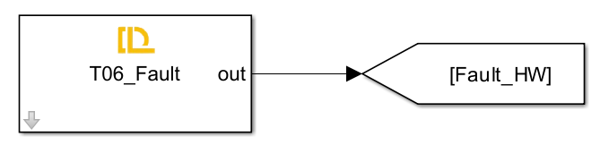
Fault_SW
To ensure safe operation, a fault is triggered when the DC link exceeds 120 V or the absolute inverter supply current exceeds 1 A. Once a fault occurs, it is latched — meaning the fault remains active even if the conditions return to normal. The fault can only be reset if the user presses the reset button and both the voltage and current fall below their respective thresholds.
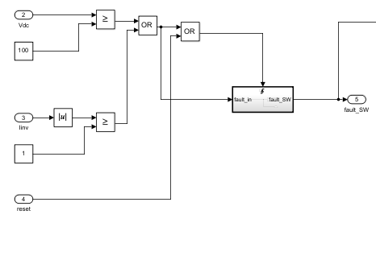
- Protection Logic
In the target model, several control constraints are implemented to ensure safe and reliable operation of the buck converter. These include:
- The enable_target signal is activated only when:
  - enable_host = 1 and
  - No hardware or software faults are present.
- The Relay_target signal (which allows connection of the AC source to the DC link) is set only when:
  - relay_host = 1 and
  - No hardware or software faults are present.
- The discharge_target signal (used to safely discharge the DC link capacitor) is activated only when:
  - Discharge_host = 1 and
  - Relay_target = 0 (ensuring no charging source is connected while discharging to avoid overload).
- The D_target signal is updated with the value from the host (D_host) only if enable_target = 1; otherwise, it is forced to zero.
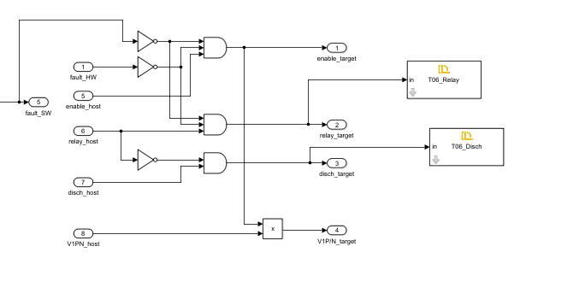
These constraints are essential for the following reasons:
- Safety: They prevent power flow or switching commands when a fault is detected, reducing the risk of hardware damage or electrical hazards.
- Controlled Discharge: They avoid discharging the capacitor while the relay is still connected to the power supply, which could cause dangerous short circuits.
- Predictable Behavior: Ensuring switching only occurs when explicitly allowed by both host and safety logic improves the reliability and traceability of system behavior.

Step 3: Target Model TX
To observe the target’s real-time operation in the Host model, signals including relay, DC discharge, control enable, software and hardware faults, Vdc, Iinv, etc, are transmitted back to the host.
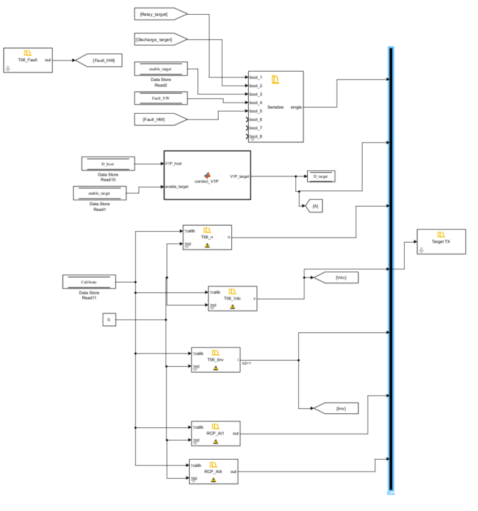

See tutorial 'Host-Target Communication' for details.

Step 4: Target Model Build, Deploy and Start
Once deployed, the DL RCPCORE runs the target model continuously at startup, while certain parameters and commands rely on real-time host communication.

Step 5: Host Model
The Host model consists mainly of:
- Host–Target communication
  - RX blocks (to receive status, measurements, fault flags).
  - TX blocks (to send commands: Relay_host, Discharge_host, Enable_host, Reset, D_host, etc.).
  - Proper framing and timing configuration.
- Dashboard / GUI
  - Switches and knobs:
    - Relay command
    - Discharge command
    - Enable command
    - Reset button
    - Duty command (D_host slider).
  - Displays and scopes:
    - DC link voltage (Vdc)
    - Inverter current (Iinv)
    - Fault indicators
    - Duty values
For details on how to implement the Host side communication and dashboard, refer again to the “Host–Target Communication” tutorial.

